CSC 4350: Software Engineering

Fall 2016 Semester

October 2, 2016

Document # 3 – System Analysis

Team Name: Real Team 6

Application Name: Booki

Team 6 Members:

Anthony Jones

McKenzie Rochester

Daniel Campbell

Jeff Sikala

Jordan Smith

Table of Contents

Problem Statement3

Requirements Trace Matrix (RTM)4

Use Cases with Rational

UC_01_AccountLogin5

UC_02_AccountRegistration6

UC_03_UpdateAccount7

UC_04_BookPost8

UC_05_PrivateMessenger9

UC_06_TransactionSystem10

UC_07_SearchMenu11

Interaction Diagrams (ID)

ID for Use Case #112

ID for Use Case #213

ID for Use Case #314

ID for Use Case #415

ID for Use Case #516

ID for Use Case #617

ID for Use Case #718

Prototype19

Database Description20

Work Share Document (WSD)21

Gantt Chart22

Dictionary23

**Problem Statement**

Booki is a web application designed for college students. We are providing a way for students to earn a portion of their money back from books, by allowing them to set their own prices and participate in transactions with other students, instead of having a middle man. To keep the transaction process purely tailored for the user, Booki does not participate in nor conducts any sales through the application, but rather gives users the ability to control their own buying, selling, or trading experience.

Booki shall prompt the user to log in using their email and password, and the application will perform authentication or enact the proper security methods. If the user does not have an account, Booki shall prompt user to create one. The web application shall allow users to create a new account via a registration page. The application will take the user to their account page, where they can view their book postings, transactions and messages. The application shall allow a user to update their account information if they choose to.

Booki will allow users to make new book listings so that the public can see what books are available. Selling, buying, and trading of books shall be handled by the users through private messaging. Booki shall prompt the users for information about their agreed upon transaction (price, location & time), and notify each party of the terms in the form of an email and notifications. The web application will not handle any monetary transactions.

Once the transaction has taken place, Booki shall prompt both users exactly an hour after the scheduled time to update the status of the transaction. This prompt will verify the completed transaction on both sides and allow each user to rate his or her experience. If the prompt is not completed neither user will be allowed to initiate another transaction until it is completed.

Booki shall have a search menu, allowing the user to search for their specific books and courses by different search categories. The web application will run on a Linux server and utilize SQLite as its database.

**Requirements Trace Matrix (RTM)**

|  |  |  |  |
| --- | --- | --- | --- |
| Entry Number | Paragraph Number | RTM Entry | Type |
| 1 | 2.1 | User is prompted to login using email and password | SW |
| 2 | 2.2 | If the User does not have an account, then the user will be prompted to create a new account. | SW |
| 3 | 2.3 | The web application will redirect a new user to an account registration page when they are directed to make one. | SW |
| 4 | 2.4 | The user will be taken to their timeline page where they can view book postings, transactions and messages. | SW |
| 5 | 3.1 | Users are about to create book postings when they are ready to sell their items. | SW |
| 6 | 3.2 | Book Transactions will send a notification and email to both the potential seller and buyer when a transaction is complete. | SW |
| 7 | 3.3 | The application will send a notification and email to the potential seller and buyer when a transaction is complete. | SW |
| 8 | 3.4 | The application will allow users to update their account information via an update page. | SW |
| 9 | 4.1 | The application will ask the users to update the status of the transaction one hour after completion. | SW |
| 10 | 4.2 | A survey will be initialized to ask the buyer how satisfied they were with the seller. | SW |
| 11 | 4.3 | If the survey is not complete, then the system will not allow another transaction until it has been completed. | DR, SW |
| 12 | 4.4 | A search menu will be used to find books by specific categories. The search option will be able to search by book title, ISBN, course, and major. | SW |
| 13 | 4.5 | The application will run on a Linux server. | HW |
| 14 | 4.6 | The application will utilize SQLite as its database system. | HW, SW |

**Use Case # 1**

|  |  |
| --- | --- |
| Use Case Name | UC_01_AccountLogin |
| Actors | Student |
| Flow of Events | 1. Enter email into email field.  2. Enter password into password field.  3. Click on button, “Login”.  4. If email or password fail, allow user to try again.  5. Once validated, redirect user to account timeline webpage. |
| Entry Condition | Student should be on login webpage of Booki’s website. |
| Exit Condition | Student will be redirected to their account timeline page. |
| Quality Requirements | The account login should allow the student to login to their account timeline with no issues. There will also be a link to redirect them to create a new account if the student is a new user to Booki. |
| Rational | Booki needs a login section in order to allow students to see their account and content. If we did not have a login, it would be impossible to allow student accounts to be personally tailored to them. |
| Scenario | 1. Student is lead to the login webpage, but clicking on the “Login” link in the navigation bar of the website.  2. The student enters their email and password.  3. If there are any issues such as the password is wrong, or the account does not exist, then the student will be able to try again. |

**Use Case # 2**

|  |  |
| --- | --- |
| Use Case Name | UC_02_AccountRegistration |
| Actors | Student |
| Flow of Events | 1. Go to account registration URL.  2. Enter the following into the account creation fields: first name, last name, username email, password.  3. Click on “Register” button to process account registration.  4. Process new account creation.  5. Redirect student to login page once new account has been created. |
| Entry Condition | A new student who is ready to create a new account will be able to access the account creation page. |
| Exit Condition | Student will be redirected to Booki’s login page to login to their new account. |
| Quality Requirements | The account registration page will check if the email and username that they selected is unique. If it is, then a new account will be a created. |
| Rational | An account creation process must be implemented in order to create new users for the system. |
| Scenario | 1. Student is lead to the account registration page by the navigation bar or from the login webpage.  2. The student is prompted to create a new account by filling out a new account creation form.  3. Once the new account credentials have been verified then the student will be redirected to the login page where they can login with their new account. |

**Use Case # 3**

|  |  |
| --- | --- |
| Use Case Name | UC_03_UpdateAccount |
| Actors | Student |
| Flow of Events | 1. Update first name, last name, email, password, major.  2. Check if email already exists in database. If it does, inform student that email is already in use.  3. Update remaining fields into database.  4. Redirect student back to their timeline.  5. Alert student that their account has been updated. |
| Entry Condition | Student should be logged into their account to be able to update their account. |
| Exit Condition | Once all parameters have been verified, then the system will redirect the student back to their timeline. All information will be updated in the database for the student. |
| Quality Requirements | The update should verify that the email that the student is trying to update is not already in the database. Emails are considered unique values in Booki, thus one email association per account. |
| Rational | Students should have the option to update their information so that they can remain up to date on their personal information. |
| Scenario | 1. Student clicks on “Update Account” link in the navigation bar of the website.  2. Student will be able to update their first name, last name, email, password, or major.  3. Once the system has verified their update, the system will redirect the student back to the timeline webpage.  4. The student will be notified that their account has been updated. |

**Use Case # 4**

|  |  |
| --- | --- |
| Use Case Name | UC_04_BookPost |
| Actors | Student |
| Flow of Events | 1. Select “Post Book” button.  2. Enter book title, ISBN, book author, condition, major, course, additional comments.  3. Click on button, “Submit”.  4. Send information to the database as a new book post.  5. Once book post has been created, redirect student back to timeline page.  6. Notify student that their new book post has been created.  7. Student can choose to hide post if someone is interested in book. |
| Entry Condition | Student should be logged into their account. Student should click on the “Post Book” button. |
| Exit Condition | Student will be redirected back to their timeline. Book will be visible on the student’s timeline. |
| Quality Requirements | The book should immediately post to the student’s timeline. |
| Rational | Booki needs a book posting option so that students are able to post the books that need to sell through the web application. |
| Scenario | 1. Once the student clicks the button, the app shall present the student with a form with information pertaining to the book.  2. Student fills out form with the book title, picture of the book, price, and additional comments.  3. Student clicks the “Submit” button.  4. If the posting process is successful, the app with direct the student back to their timeline with the newly added book displayed.  5. Else if the posting process is unsuccessful, an error message will appear to the bottom of the form, stating what went wrong.  6. If the student has someone interested in their book, they can choose to hide or delete the post until transaction is complete. |

**Use Case # 5**

|  |  |
| --- | --- |
| Use Case Name | UC_05_PrivateMessenger |
| Actors | Buyer, Seller |
| Flow of Events | 1. Select book post.  2. Display further details about book in separate webpage  3. Click on Message Seller  4. Send message and notification to the seller.  5. Buyer can see message sent in separate window.  6. Buyer may reply by clicking reply within that window.  7. Seller completes transaction. |
| Entry Condition | Student should be logged into their Booki account. Student should be able to click on “Message Seller” |
| Exit Condition | Student will be redirected to the private message conversation webpage between the buyer and seller. Seller can complete the transaction in the message. |
| Quality Requirements | The private messaging system should send messages instantaneously. A notification will be shown once a message has been sent. |
| Rational | The application must have a private messaging system so that buyers and sellers can trade their items. Since we will not be facilitating monetary transactions, students need to have the feature to talk to each other in order to complete private transactions. |
| Scenario | 1. Buyer shall select a book that they wish to purchase.  2. Buyer will click on “Message Seller” button if they wish to initiate a private message to the Seller.  3. The seller will receive and notification from the potential buyer.  4. The seller can continue sending messages to the potential buyer.  5. Once a personal transaction has been completed, the seller can hide the post to avoid any double selling.  6. Once the buyer and seller have met up and the transaction is complete, the seller will be able to go back into the messages, and click on transaction complete, sending a notification to the buyer to rate the seller. |

**Use Case # 6**

|  |  |
| --- | --- |
| Use Case Name | UC_06_TransactionSystem |
| Actors | Buyer, Seller |
| Flow of Events | 1. Seller clicks on “Transaction Complete”  2. Send survey to buyer in order to rate the seller.  3. Buyer rates seller.  4. Process survey and hides book post from the public.  5. Update seller rating. |
| Entry Condition | Buyer and seller need to logged into their respected accounts. The transaction will be initialized from the private message. |
| Exit Condition | One the transaction is completed, the system will hide the book post from the public and update the seller’s rating. |
| Quality Requirements | A notification will be sent to the buyer if they have not rated the seller. The notification will appear in buyer’s timeline and will not go away until they have rated. Ratings will help sellers by reassuring potential buyers that the seller is reputable among other buyers. |
| Rational | Booki needs a transaction system in order to process what book posts are still available. It also helps the experience of trading books by giving seller’s a rating. |
| Scenario | 1. The seller will initiate “transaction complete” once their personal transaction with the buyer has been finished.  2. At this point, the buyer will receive a survey to rate their experience with the buyer.  3. Once the seller as has completed the survey, the post will be hidden from the public view since the book will no longer be available.  4. The sellers rating will be updated after the survey is completed. |

**Use Case #7**

|  |  |
| --- | --- |
| Use Case Name | UC_07_SearchMenu |
| Actors | Student |
| Flow of Events | 1. Click on drop down menu for search.  2. Select search category.  3. Click submit.  4. Perform query for selected search category.  5. Return selected items from database.  6. Display items to the student. |
| Entry Condition | Student needs to be logged into their account to use the search menu functionality. |
| Exit Condition | Student will see their search query results after they click submit. |
| Quality Requirements | The search menu should accurately show the requested results. SQL select statements will be used and will be tuned to each specific category. |
| Rational | It is necessary to implement a search menu so that student will be able to find the books that they need. Also this helps sellers sell their items by making them available to all students. |
| Scenario | 1. Student click on search drop down menu.  2. Student will select a search category to query.  3. Booki will perform select queries based on the search category.  4. The web application will display the results of the selected query.  5. Students will see all the book posts based on the search query. They can then select each individual post and initiate a private message if they are interested in the book. |

**Interaction Diagram for Use Case #1**

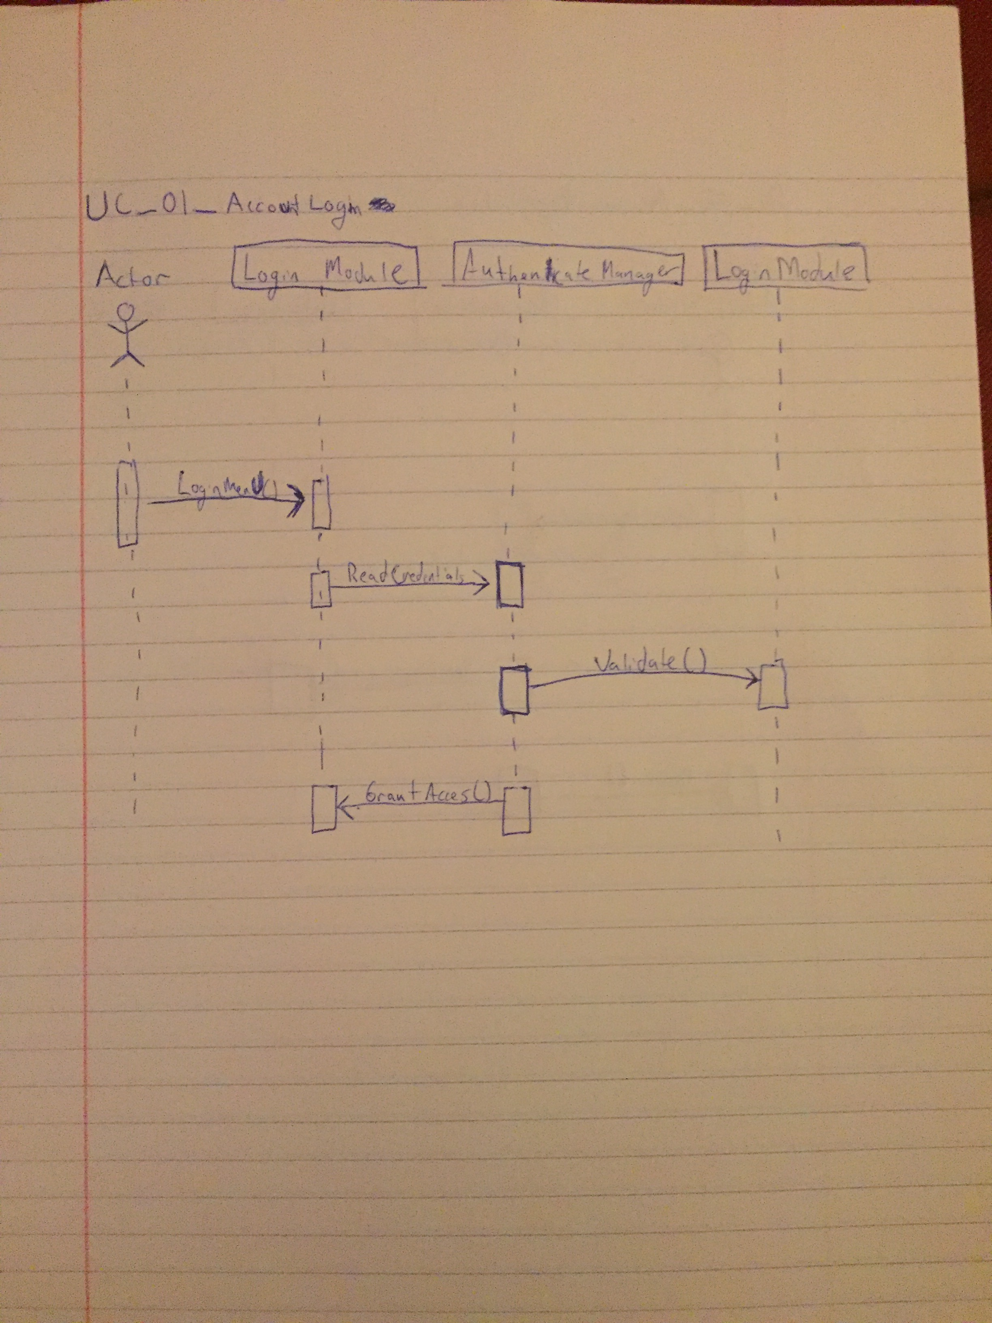

**Interaction Diagram for Use Case #2**

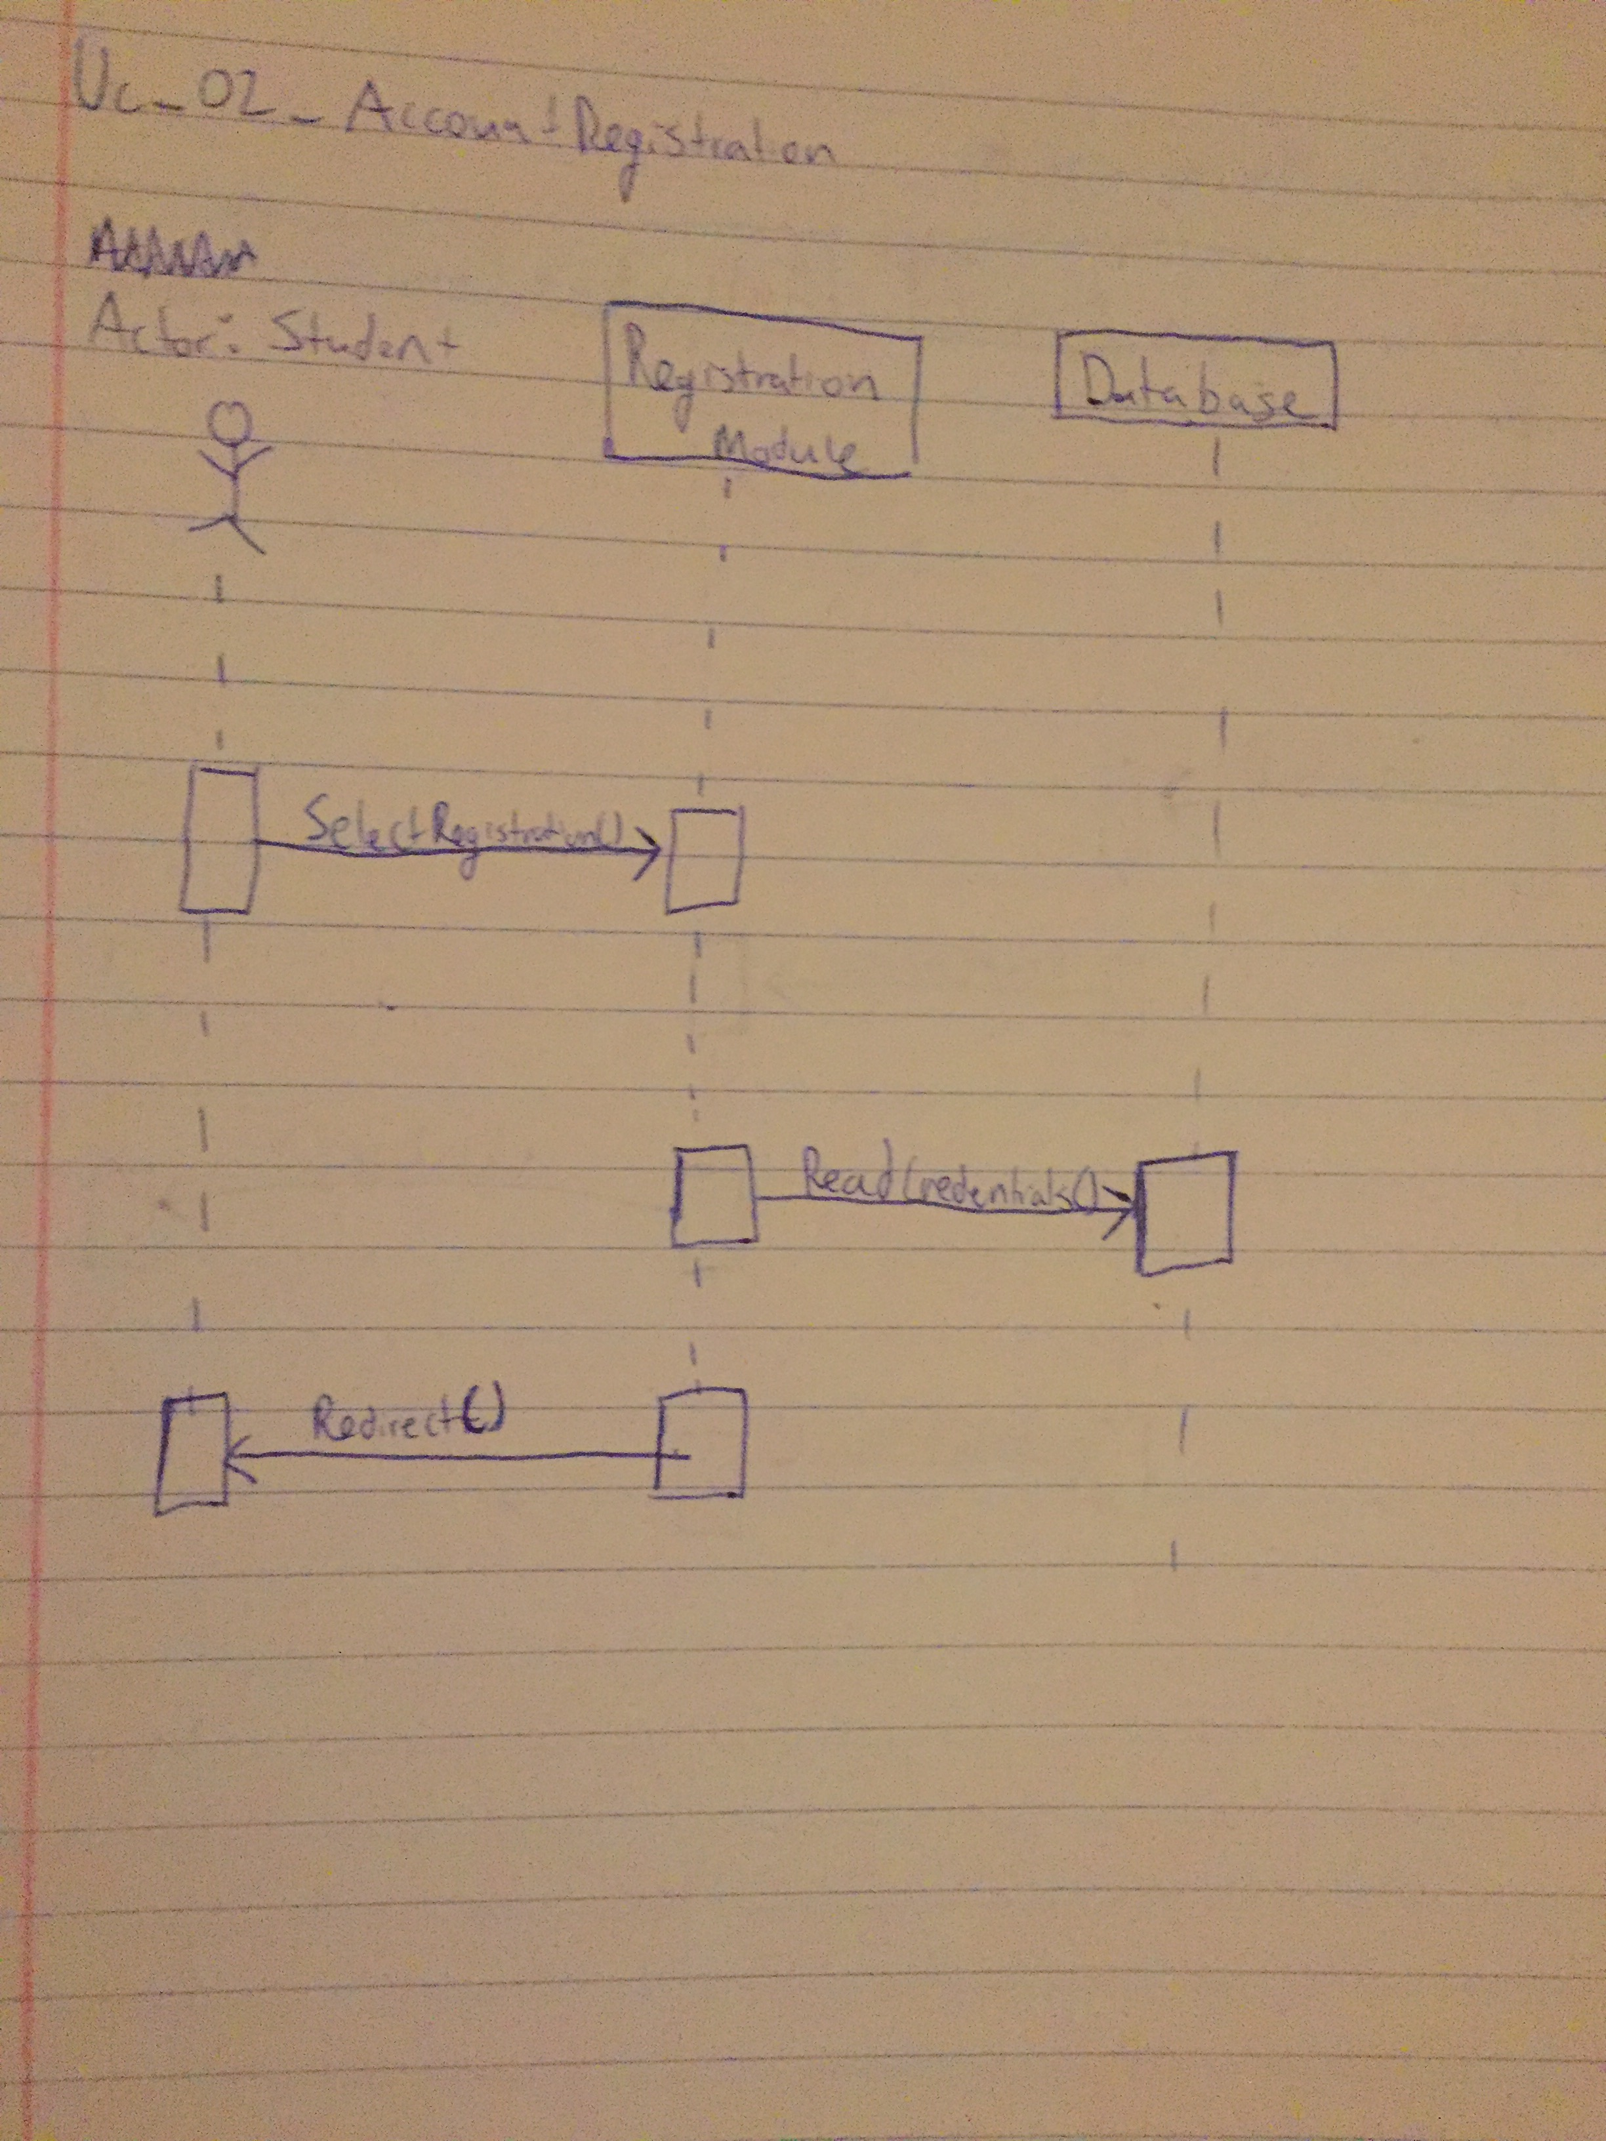

**Interaction Diagram for Use Case #3**

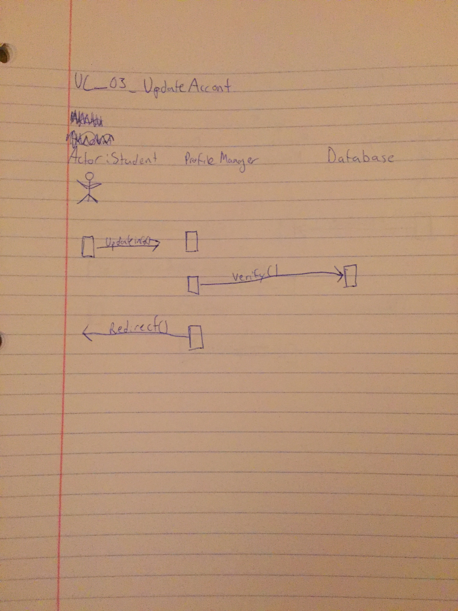

**Interaction Diagram for Use Case #4**

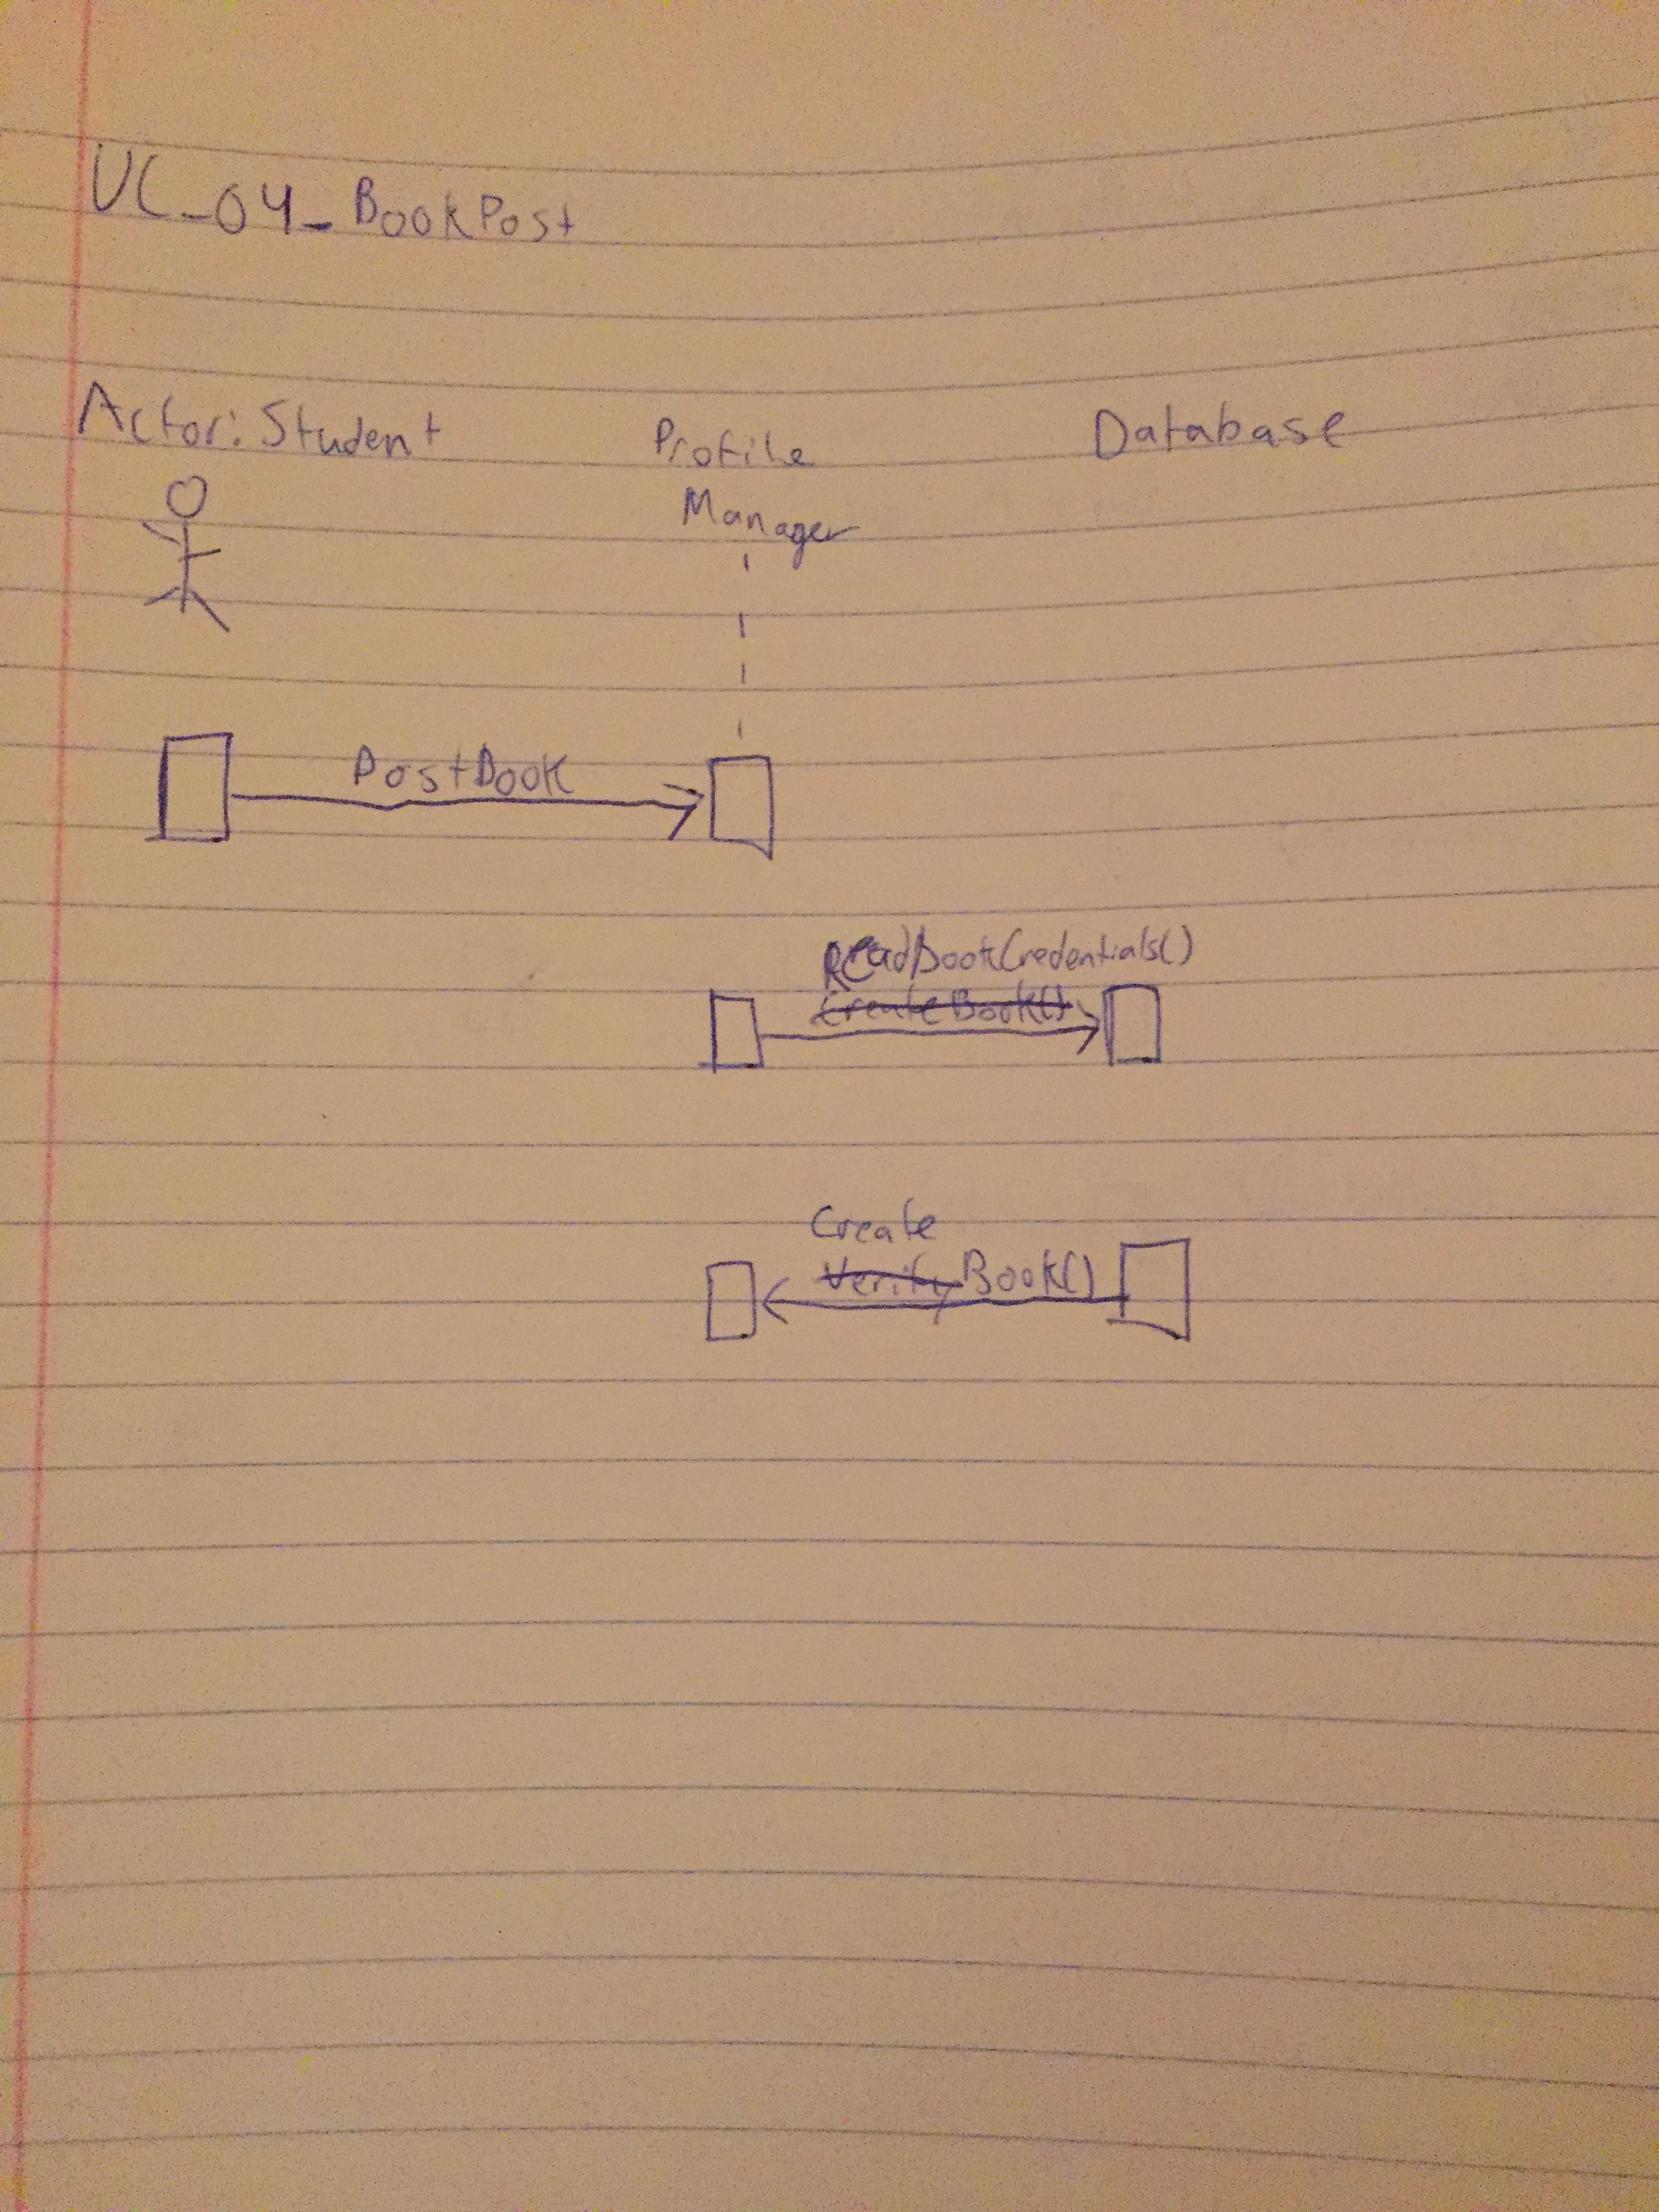

**Interaction Diagram for Use Case #5**

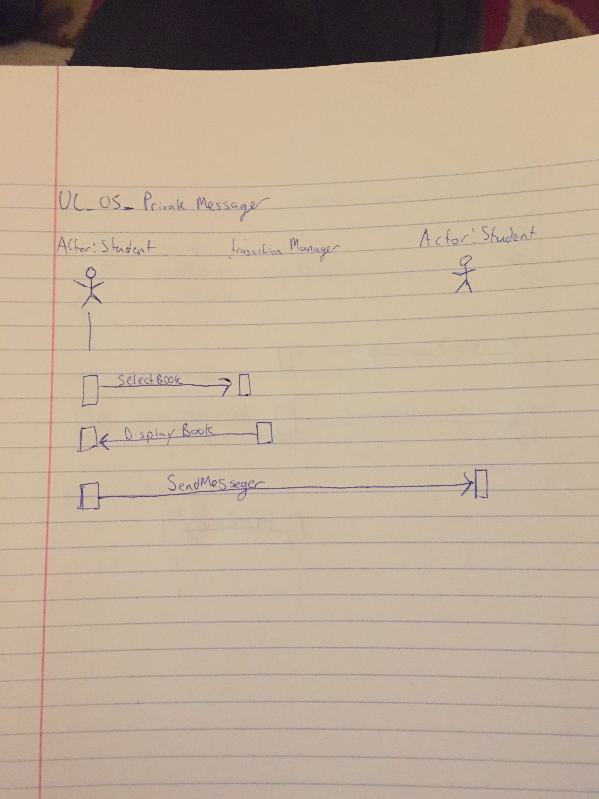

**Interaction Diagram for Use Case #6**

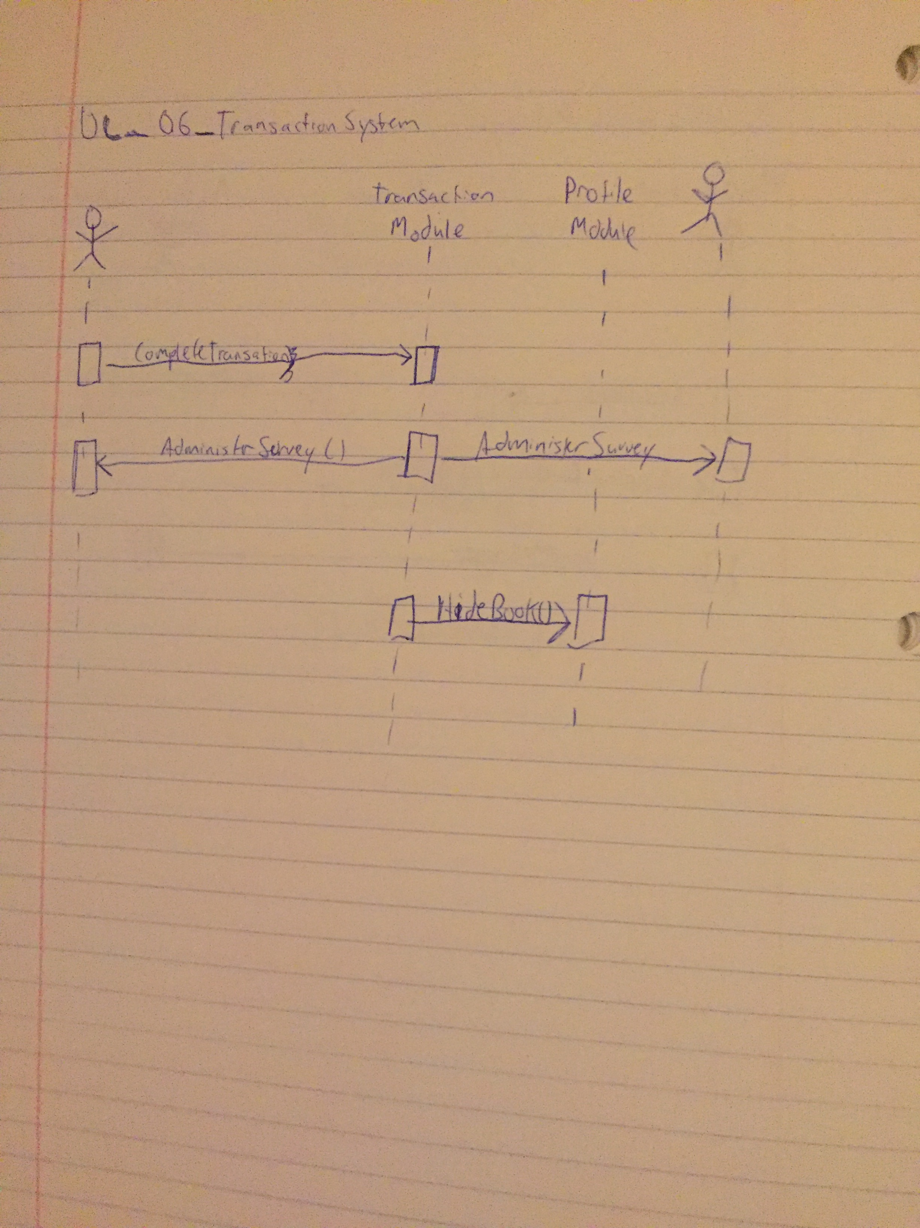

**Interaction Diagram for Use Case #7**

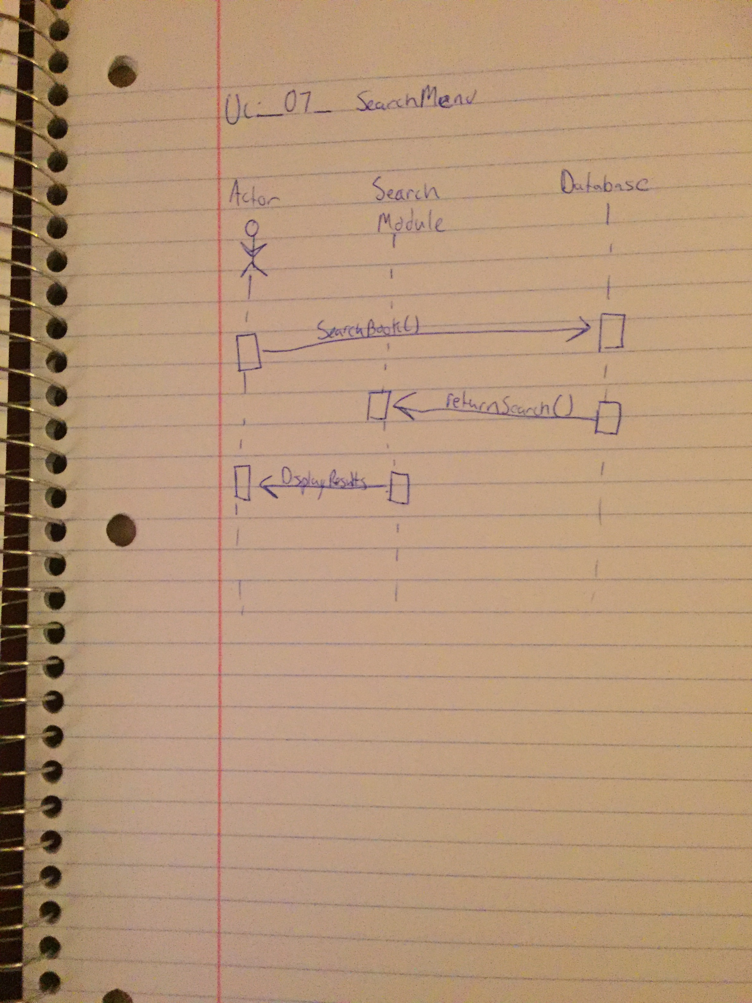

**Prototype**

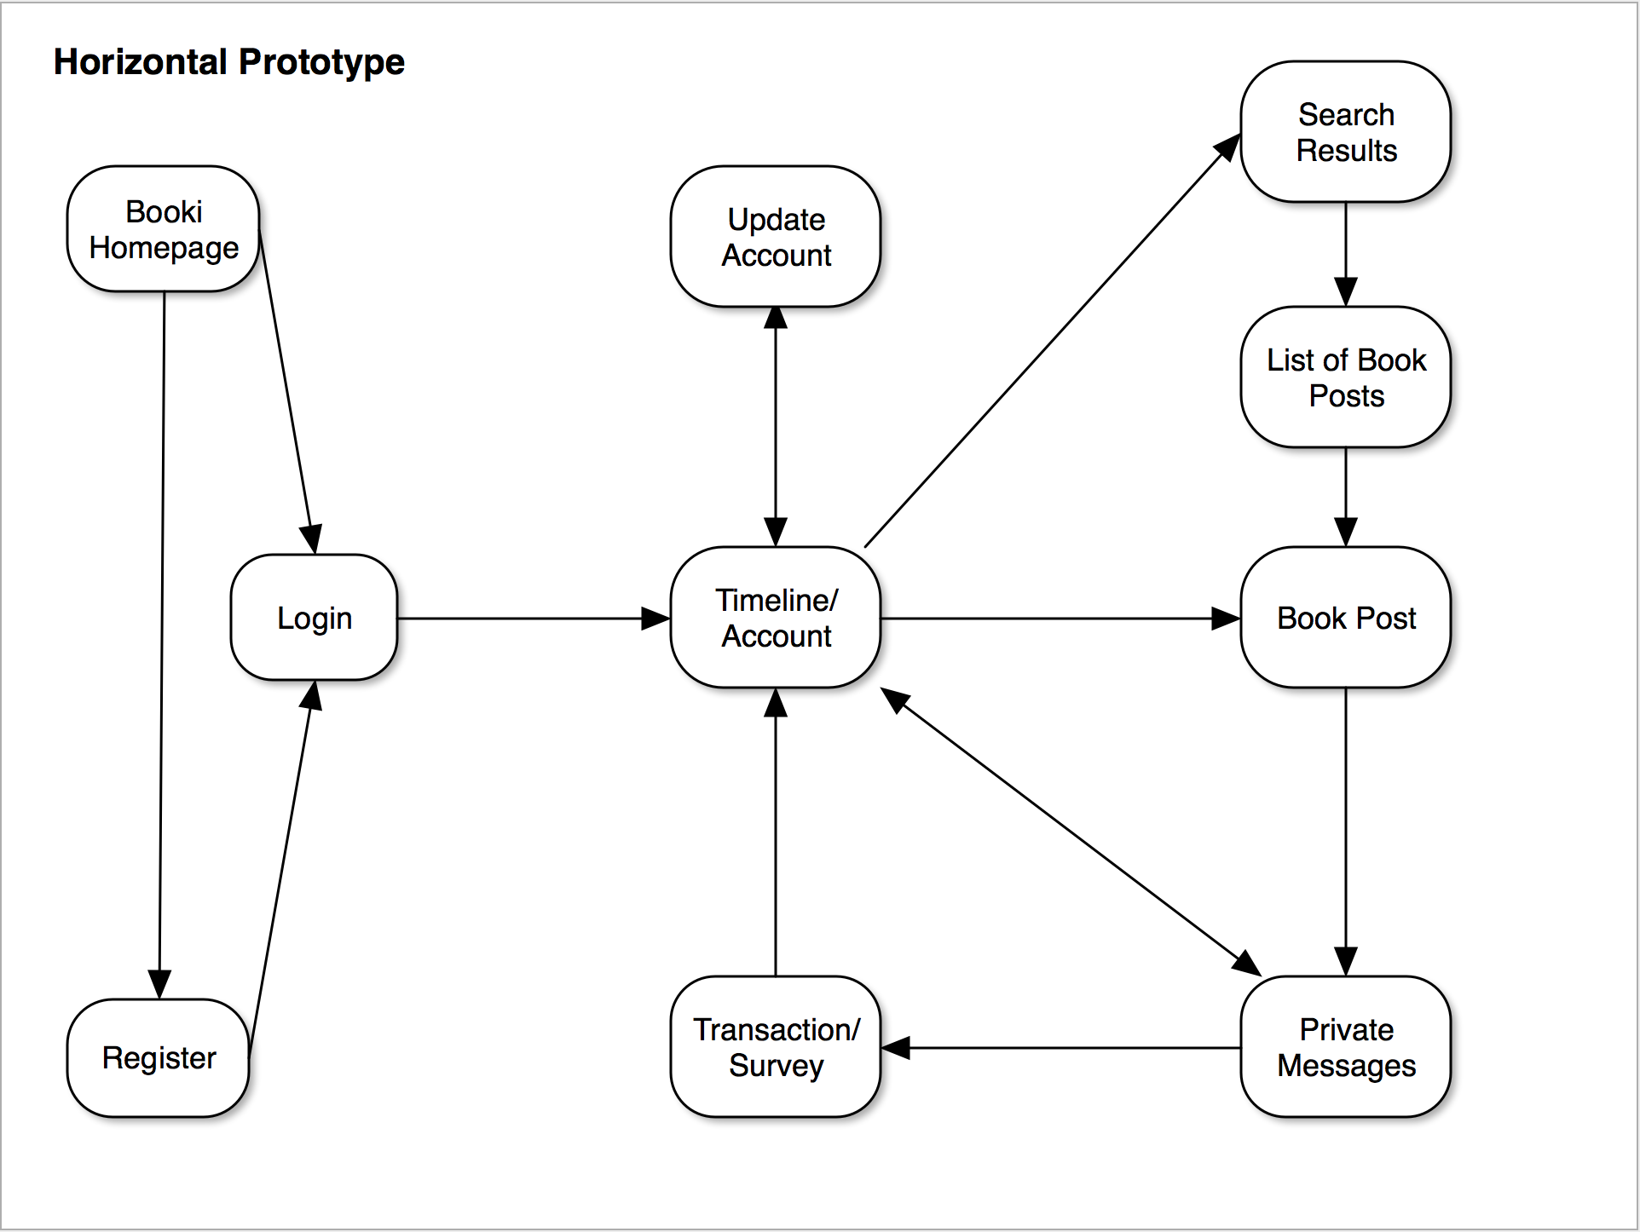

**Database System**

Booki will implement SQLite as its database system. SQLite is a relation database management system that is lightweight and easy to use. SQLite is an excellent solution for our web application for many reasons. It does not require a separate server process. It can read and write directly to ordinary disk files. In fact, the entire database can be stored in one file. SQLite is a great solution for low to medium traffic sites. Since Booki is new application we can rely on the simplicity of SQlite. It can handle traffic of about 100,000 hits per day, so it will be sufficient for the uses of Booki.

**Work Share Document (WSD)**

**Daniel Campbell**

Role: Front-End Programmer

**McKenzie Rochester**

Role: Back-End Programmer

**Jeff Sikala**

Role: Database Programmer

**Jordan Smith**

Role: Technical Writer

**Anthony Jones**

Role: Team Leader/Client/Tester

**Project Timeline (Gantt Chart)**

October 2, 2016

|  |  |  |  |  |
| --- | --- | --- | --- | --- |
| Task | Task Description | Duration (Days) | Start Date | End Date |
| Introduction | | | | |
| 1 | Team Creation | 3 | 23-Aug | 25-Aug |
| 2 | Identify Team Roles | 3 | 25-Aug | 27-Aug |
| 3 | Identify Project Idea | 4 | 27-Aug | 1-Sept |
| 4 | Work Sign Document (WSD) | 5 | 28-Aug | 1-Sept |
| Requirement Elicitation | | | | |
| 5 | Problem Statement | 3 | 13-Sept | 17-Sept |
| 6 | Requirements Trace Matrix (RTM) | 2 | 17-Sept | 18-Sept |
| 7 | Gantt Chart | 2 | 17-Sept | 18-Sept |
| 8 | Dictionary | 2 | 17-Sept | 18-Sept |
| 9 | Project Rational | 2 | 17-Sept | 18-Sept |
| System Analysis | | | | |
| 10 | Updated Problem Statement | 3 | 19-Sept | 21-Sept |
| 11 | Update RTM, Gantt Chart, Dictionary | 3 | 22-Sept | 24-Sept |
| 12 | Use Cases | 9 | 24-Sept | 2-Oct |
| 13 | Interaction Diagrams | 1 | 2-Oct | 2-Oct |
| 15 | Horizontal Prototype | 1 | 2-Oct | 2-Oct |

**Dictionary**

* Web Application: A client server software application in which the client runs in a web browser.
* Database: A location where data is stored. It uses a language called SQL to issue commands to it. In our project we will be using SQLite as our database.
* URL: Uniform Resource Locator. Provides an address to a location on the world wide web.
* Redirected: Takes a user from one website to another website typically through a hyperlink.
* Query: A command for SQL databases.
* App: Short for application.
* Web Browser: A software application for retrieving, presenting, and traversing informational resources on the world wide web.
* Course: A class that is offered by a university or college.
* Web Browser Credentials: Information that is temporarily stored within the web browser in order to keep a user logged into the system for a period of time.